**Exp 3.**

**Preparation of Competent *Escherichia coli* and Transformation with Plasmid DNA**

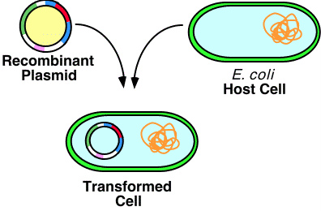

**Aims**

1. To make *E. coli* DH5αcompetent by the calcium chloride method to takeup foreign DNA or plasmid
2. To transform *E.coli*DH5α strain with plasmid DNA
3. To estimate transformation efficiency of a bacteria (number of transformants per microgram of DNA)
4. To study effect of different concentrations of Calcium chloride on competence to take up foreign DNA

**Theory**

Transformation of bacteria means introduction of foreign DNA(or plasmids) into bacterial cells. A combination of chemical and heat is commonly used for transformation in research laboratories. Some strains of bacteria are not naturally transformable, but can be artificially induced to take up DNA by chemical or electrical shock method after addition of calcium chloride. Factors such as bacterial strain, medium composition, growth phase, divalent cations, and DNA size are important in the transformation of bacteria. Actively growing cells in early log phase are more susceptible to transformation.

The bacterial cells are harvested in their log phase and made ‘competent’ using Calcium chloride. Calcium ion neutralizes the negative charge outside the cell and increase the efficiency for DNA to enter in to bacterium. During the incubation on ice, DNA comes in vicinity to the bacterial cells and heat shock creates transient pores in cell through which plasmid DNA enters into the cell. Second incubation on ice ceases the movement inside the cell and helps in stable entry of DNA in cell.

Once inside the cell, plasmids that are able to generate antibiotic resistance capacity in the bacteria will be able to replicate and form colonies on antibiotic containing LB agar plates. Antibiotic resistance capacity is generally present in the form of a gene on the plasmid.Cells with the plasmid will produce anenzyme to inactivate the antibiotic, and will thus form colonies on the plate. The enzyme which inactivates the antibiotic ampicillin is called -lactamase.

**Materials and Reagents**

*E. coli* culture, plasmid DNA, Microcentrifuge tubes, Micropipettes, Laminar hood, LB plates with ampicillin, Water bath

Brief Method Outline Log phase cells are those in the second phase in the figure

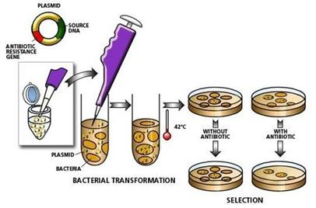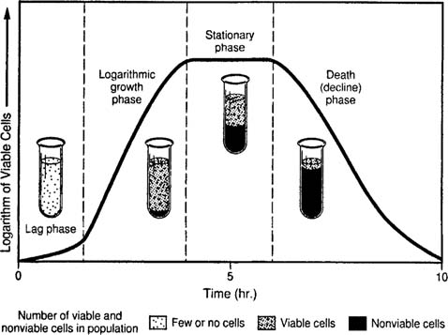

**Procedure:**

All steps should preferably be done in aseptic conditions or inside the laminar hood. We will do it on the bench.

1. You will be provided with liquid culture of the bacteria *Escherichia coli* DH5 cultures (bacteria have been inoculated in LB media and grown at 37C, and collected in the log phase by teaching staff).



1. Aliquot 0.2ml each of bacterial cultures into three1.5ml microcentrifuge tubes. Label the tubes – 1,2,3 with your initials.
2. Place the tubes in a centrifuge. Make sure that all the tubes are balanced (add a balance tube with water if necessary). Centrifugeculturesat 3500 rpm for 2 min.Discard the supernatant (which contains spent LB media) as shown above in a waste beaker and use the pellet (which contain bacterial cells)for subsequent steps.
3. Suspendone pellet in 100 micro-liter of ice-cold sterile water and keep on ice (this will be the control expt)
4. Suspend the second pellet in 100 micro-liter of 100 mM CaCl2 and keep on ice
5. Dissolve the third pellet in ice-cold 100 micro-liter of a 100mM solution of a different salt given to you. Keep tube on ice
6. Incubate all 3 tubes on ice for 15min.
7. Using micropipette add 2µl (20 nano-grams) of provided plasmid DNA to the cells, tap the tubes gently to mix cells with DNA. Incubate the mixture on ice for 30min.
8. Transfer the tubes on water bath floats. Heat shock the mixture of cells,saltand DNA at 42°C for 60 seconds in a water bath.
9. Bring the tube back on ice. Incubate for 5min.
10. Add 1ml of LB media without antibiotic. Incubate the mixture on a shaker at 37°C at 250rpm for 15-30min to revive the cells.
11. Plate100µl of cells on ampicillin containing LB plates. Remember for calculation of transformation efficiency later that you are plating only one-fifth of total volume.
12. Incubate the plates at 37°C for 14-16 hours.
13. Next day (After 16 hours), whenever you have time, drop by tocount number of coloniesgrowing on the different plates. What do you observe, and what can you conclude ?
14. Calculate transformation efficiencies (number of colonies per micro-gram of plasmid DNA).

